Charlie, Claudiu, Ryan and Tania

COSC 257 Final Design Document

9/24/23

**Overview**

Prof. Miller regularly collects lycium plants from different parts of the world, brings them to Amherst, and samples their DNA. There are over 3000 samples. Each sample is stored with a unique identifier (field id) as well as some basic information pertaining to where and when it was located. She currently uses a website built on PHP and MySQL but it is incredibly outdated and difficult to navigate. We will be upgrading the site by migrating to PostgreSQL, building a new UI/UX, as well as by implementing a way to export the data to a .csv file. The existing site can be found here - [https://jsmiller.people.amherst.edu/Lab/Miller_Lab_Home.htm](https://jsmiller.people.amherst.edu/Lab/Miller_Lab_Home.html)l.

**ER Diagram**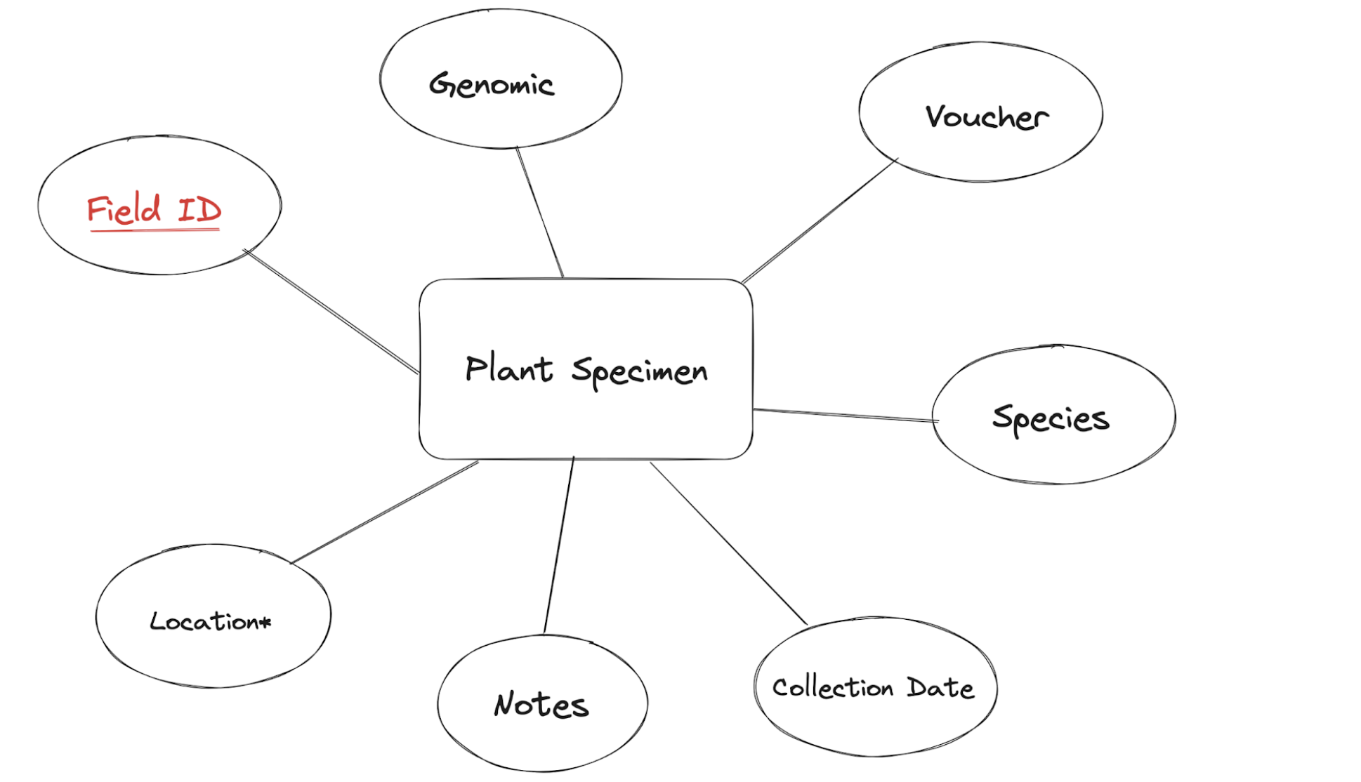

**Technology Proposal**

If using an ORM as opposed to actual SQL code is permitted, Charlie has significant frontend experience with the “T3” stack which includes Next.js, Prisma, Tailwind, TRPC and believes that those technologies will be a perfect fit for the task at hand. If not, we plan to build the frontend using React.js, with a Node.js backend communicating with a PostgreSQL database.